EXPERIMENT 3 LINEAR RERESSION MODEL
AIM
To develop a linear regression model for time series data
PROCEDURE
1. Import the necessary libraries:
import pandas as pd
import numpy as np
import matplotlib.pyplot as plt
import seaborn as sns
from sklearn.model_selection import train_test_split
from sklearn.linear_model import LinearRegression
from sklearn.metrics import mean_squared_error, r2_score

2. Load dataset
df = pd.read_csv('Toddler.csv')
3. Display basic statistics
print(df.describe())
4. Selecting features and target variable
X = df[['Age_Mons']]
y = df['Qchat-10-Score']
5. Split into training and testing sets
X_train, X_test, y_train, y_test = train_test_split(X, y, test_size=0.2, random_state=42, shuffle=True)
6. Train the Linear Regression model
model = LinearRegression()
model.fit(X_train, y_train)

7.Make predictions
y_pred = model.predict(X_test)

8.Evaluate the model
mse = mean_squared_error(y_test, y_pred)
r2 = r2_score(y_test, y_pred)
print(f"Mean Squared Error: {mse}")
print(f"R² Score: {r2}")

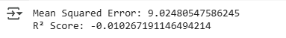

9.Visualizing the results
plt.figure(figsize=(10,5))
plt.scatter(X_test, y_test, color='blue', label='Actual')
plt.plot(X_test, y_pred, color='red', linewidth=2, label='Predicted')
plt.xlabel('Age in Months')
plt.ylabel('Qchat-10 Score')
plt.title('Linear Regression for Autism Screening Score by Age')
plt.legend()
plt.show()
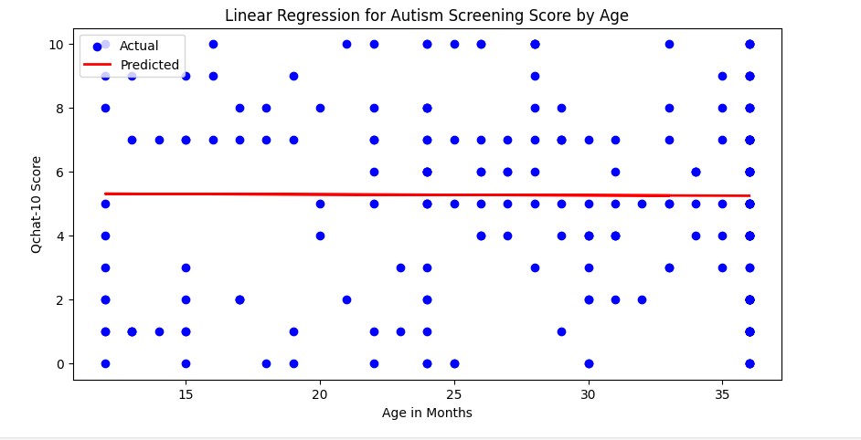

RESULT:
Thus the linear regression model for time series analysis on the autism dataset implemented successfully.

